S & M-CM/164/STV-BOOSTER CARDS/11-12/36 dt @ Chennai-6 the 08.08.2011.

Sub: Activation of new Voice STV/Boosters through C-TOP-UP & SMS in 2G/3G prepaid services - reg.
Ref: C.O. lr No: 26-07/2011-T&C-CM Circular No:42/11-12 dt 01/08/11.

Approval of the competent authority is hereby conveyed for the revision of the following STVs through C-TOP-UP (and also through SMS) in 2G/3G Prepaid mobile services in Tamilnadu LSA (including Chennai Telecom District) with effect from 09.08.2011.

The details are given below:-

STV Feature | Validity in days | MRP of STV in Rs.(through C-TOP-UP) incl. of S.Tax |  | Amount to be deducted in IN for revised MRP (Rs.) | Format for sending SMS to 53733 for the revised STV
STV Feature | Validity in days | Existing | Revised | Amount to be deducted in IN for revised MRP (Rs.) | Format for sending SMS to 53733 for the revised STV
Local/STD On-net Night @ 5p/Min (11PM to 06AM) | 30 | 17.00 | 35.00 | 31.73 | VOICE35
Local On-net @ 10p/Min | 30 | 54.00 | 65.00 | 58.93 | VOICE65

All other terms and conditions, SMS activation procedure will remain same. Consequent to this revision, the C-TOP-UP denominations 17 & 34 and SMS format VOICE17 & VOICE54 stands withdrawn.

This is for the information of all concerned please.
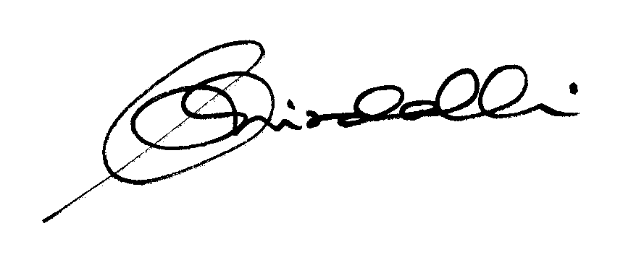

(K.R. Aravindavalli)

AGM(Marketing-CM)

To

GM (NW-O CM), Trichy -1/ Coimbatore – For information & necessary action please.
GM(S&M-CM), Chennai Telephones, Chennai – for information please.
GM (F) / Sr. GM (TR) TN Circle, Chennai for information please.
DGM /DE In charge IN – Trichy - for necessary action please.
DGM (N/W-O-CM)/DE Commercial Coimbatore - For information & necessary action please.
Heads of SSAs, -- for kind information and necessary action please.
DGM (Sales), AGM (Sales) & AGM (MKTG II)- Chennai-6 –For information and informing Sales Heads , franchisee managers and retail managers and other Channel partners along with commission structure as applicable.
DGM (CS), Chennai-6 - For information and informing Call Centre/Customer Service Centre Officials and ensure uploading the information on the website “tamilnadu.bsnl.co.in” .
DGM (S&M-CM)/AGM (MKTG-CM), Chennai Telephones, Chennai – for information & necessary action please.

